Student’s absence from school – information for the parents April 2021
The children's school attendance is important and continuous participation in the educational process is the foundation for good schooling and well-being.
The Executive Order for Students' Absence from School sets a framework for absence and describes who is responsible.
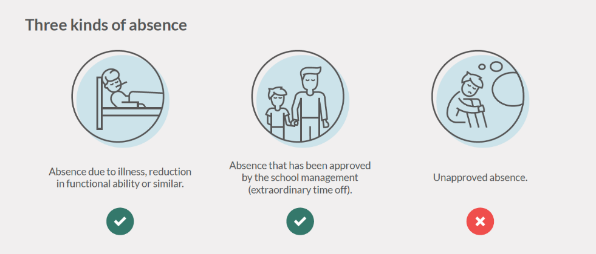
It is the parents' duty to inform the school about a child's absence. Likewise, the school has a responsibility to register absence and inform the parents.
In case of an unapproved absence rate of 10% within a quarter, the school sends a warning letter about excessive absence.
In case of an unapproved absence rate of 15%, parents/guardians are informed, and a notification is made to the Family Department.
Read more about absence at the Ministry of Education webpage: Undervisningsministeriets hjemmeside
MU|Elev|FRAVÆR (MU|Student|ABSENCE) – this is how to report an absence
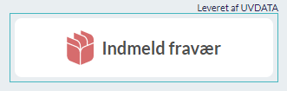
From Tuesday, April 6th, 2021, all reporting of absence should be done via the system MU|Elev|FRAVÆR.
You can find MU|Elev|FRAVÆR to the right at the front page of Aula. Press:
In the video below you can see how absence is reported to the school:
Scan the code to the right with the camera on your phone to watch the video:

It is possible to report an absence in the form of illness or your wish for extraordinary time off, e.g., dentist.
If the student is absent from school and the parents have not reported absence, the absence is registered as Unapproved.
The system sends an SMS to parents/guardians with a reminder of registration of absence.
Cf. the Executive Order the school is obliged to inform parents in case of absence. The school has chosen to do this via SMS in MU|Elev|FRAVÆR. Here it is also possible to follow the child's absence.
The absence system MU|Elev|FRAVÆR does not replace the ongoing dialogue between school and home but must support that the mandatory registration of absence is made correctly.
If you have questions about absence registration, you are always welcome to contact us.

